**Summer Internship Report**



Neural Network and Deep Learning

***Submitted By:***

Rithwick Negi

18csu173

# **CERTIFICATE**

We hereby declare that the work being presented in major project report entitled **“Deep Learning and Neural Network”** towards the partial fulfillment of the requirement for the award of degree of **Bachelor of Technology** in **CSE & IT** is an authentic record of our own work .

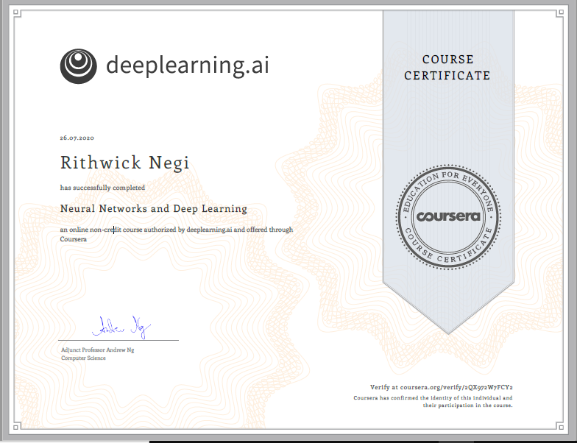

**ACKNOWLEDGEMENT**

Presentation inspiration and motivation have always played a key role in success of any venture.

## I express my sincere thanks to Prof **Andrew Ng f**or guiding me throughout the course and making me understand complicated topic so easily.

## I feel to acknowledge deep sense of gratitude to my Head Teaching Assistant - **Kian Katanforoosh** whose valuable guidance and kind supervision given me which shaped the present work as it shows.

**ABSTRACT**

Over the last years deep learning methods have been shown to outperform previous state-of-the-art machine learning techniques in several fields, with computer vision being one of the most prominent cases. This review paper provides a brief overview of some of the most significant deep learning schemes used in computer vision problems, that is, Convolutional Neural Networks, Deep Boltzmann Machines and Deep Belief Networks, and Stacked Denoising Auto encoders. A brief account of their history, structure, advantages, and limitations is given, followed by a description of their applications in various computer vision tasks, such as object detection, face recognition, action and activity recognition, and human pose estimation. Finally, a brief overview is given of future directions in designing deep learning schemes for computer vision problems and the challenges involved therein.

**INDEX**

Certificate……………………………………………………………………….. 2

Acknowledgement……………………………………………………………..... 3

Abstract………………………………………………………………………….. 4

Introduction………………………………………………………………………6

Training Objective…………..……………………………………………..…….7

About the course…………………………………………………………….........8

Instructor………………………………………………………………….............9

Course Syllabus………………………………………………………...................10

Week 1 learning outcome (Programming assignment)……………..…………...12

Week 2 learning outcome (Programming assignment)………………………….15

Week 3 learning outcome (Programming assignment)………………………… 19

Week 4 learning outcome (Programming assignment)………………………….25

Outcome on new Dataset……….……………………………………………........29

Conclusion………………………….………………………………………………30

Reference….……………………………....………………………………………..31

**INTRODUCTION**

Deep learning (also known as deep structured learning) is part of a broader family of machine learning methods based on artificial neural networks with representation learning. Learning can be supervised, semi-supervised or unsupervised. Deep learning allows machines to solve relatively complex problems even when using data that is diverse, less structured or interdependent. Deep learning is a form of machine learning that is inspired and modelled on how the human brain works. In this course we are introduced to the basics of deep learning and have learn how it compares to other techniques. During the course we have also understand the applications of deep learning in various fields and learn more about different frameworks used for neural networks.

**TRAINING OBJECTIVE**

Our objective to take this course is to learn and explore different functions, features in Deep learning and neural network. Also to make and work on a working project using deep learning and neural network. For this we created logistic regression model i.e. single layer neural network model and hidden layer neural network model.

**ABOUT THE COURSE**

Deep learning engineers are highly sought after, and mastering deep learning will give you numerous new career opportunities. Deep learning is also a new "superpower" that will let you build AI systems that just weren't possible a few years ago.

In this course, you will learn the foundations of deep learning. When you finish this class, you will: - Understand the major technology trends driving Deep Learning - Be able to build, train and apply fully connected deep neural networks - Know how to implement efficient (vectorized) neural networks - Understand the key parameters in a neural network's architecture This course also teaches you how Deep Learning actually works, rather than presenting only a cursory or surface-level description. So after completing it, you will be able to apply deep learning to a your own applications. If you are looking for a job in AI, after this course you will also be able to answer basic interview questions.

**INSTRUCTOR**

## **Andrew Ng**

CEO/Founder Landing AI; Co-founder, Coursera; Adjunct Professor, Stanford University; formerly Chief Scientist,Baidu and founding lead of Google Brain

In 2011 he led the development of Stanford University’s main MOOC (Massive Open Online Courses) platform and also taught an online Machine Learning class to over 100,000 students, leading to the founding of Coursera. Ng’s goal is to give everyone in the world access to a great education, for free. Today, Coursera partners with some of the top universities in the world to offer high quality online courses, and is the largest MOOC platform in the world.

Ng also works on machine learning with an emphasis on deep learning. He founded and led the “Google Brain” project which developed massive-scale deep learning algorithms. This resulted in the famous “Google cat” result, in which a massive neural network with 1 billion parameters learned from unlabelled YouTube videos to detect cats. More recently, he continues to work on deep learning and its applications to computer vision and speech, including such applications as autonomous driving.

## **Head Teaching Assistant - Kian Katanforoosh**

Lecturer of Computer Science at Stanford University, deeplearning.ai, Ecole CentraleSupelec

**COURSE SYLLABUS**

The course spans over 4 weeks starting with the basics and building upon it each week. It start with the most simple 1-Layer neural network in the second week and complete an L-Layer neural network in the fourth week.

**Week 1 – Introduction to deep learning**

In the first week, introductions about Neural Network and Deep Learning are discussed.

• Understand the major trends driving the rise of deep learning.

• Be able to explain how deep learning is applied to supervised learning.

• Understand what are the major categories of models (such as CNNs and RNNs), and when they should be applied.

• Be able to recognize the basics of when deep learning will (or will not) work well.

**Week 2 – Neural Networks Basics**

The second week is, in my opinion, the foundation week for the specialization. Many of the important concepts of Deep Learning are discussed. There are also refreshers on calculus and linear algebra.

• Derivatives

• Binary Classification

• Logistic Regression

• Cost Function

• Gradient Descent

• Computation graph and Derivatives with a Computation Graph

• Vectorization and Vectorizing Logistic Regression/Gradient Output

**Week 3 – Shallow neural networks**

The lectures from third week teach how to build a neural network with one hidden layer using forward propagation and back propagation.

• Two layer Neural Network

• Neural Network Representation

• Computing a Neural Network’s Output

• Vectorizing across multiple examples

• Activation functions, need for non-linear activation functions and derivatives of activation functions

• Gradient descent for Neural Networks

• Random Initialization

**Week 4 – Deep Neural Networks**

In the last week, we learn about the key computations underlying deep learning, and use them to build and train deep neural networks, and apply it to computer vision

• Deep L-layer neural network

• Forward Propagation in a Deep Network

• Matrix dimensions right

• Purpose of Deep representations

• Building blocks of deep neural networks

• Forward and Backward Propagation

• Parameters vs Hyperparameters

**WEEK-1**

**Key Points:-**

* Understand the major trends driving the rise of deep learning.
* Be able to explain how deep learning is applied to supervised learning.
* Understand what are the major categories of models (such as CNNs and RNNs), and when they should be applied.
* Be able to recognize the basics of when deep learning will (or will not) work well.

**Neural Network**

A neural network is a series of algorithms that endeavour to recognize underlying relationships in a set of data through a process that mimics the way the human brain operates. In this sense, neural networks refer to systems of neurons, either organic or artificial in nature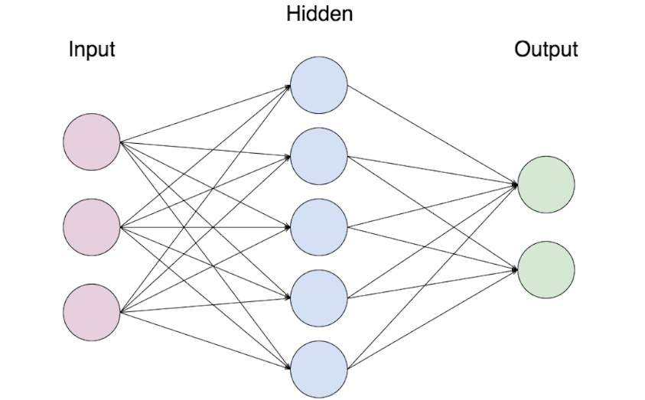

Neural networks can usually be read from left to right. Here, the first layer(called input layer) is the layer in which inputs are entered then there is internals layer (called hidden layer) that do some math, and one last layer that contains all the possible outputs(called output layer).

**How does a Neural network work?**

A neural network has a large number of processors. These processors operate parallelly but are arranged as tiers. The first tier receives the raw input similar to how the optic nerve receives the raw information in human beings. Each successive tier then receives input from the tier before it and then passes on its output to the tier after it. The last tier processes the final output.

**Supervised learning**

Supervised learning is the machine learning task of learning a function that maps an input to an output based on example input-output pairs. It infers a function from *labeled training data* consisting of a set of *training examples*. In supervised learning, each example is a *pair* consisting of an input object (typically a vector) and a desired output value (also called the *supervisory signal*). A supervised learning algorithm analyzes the training data and produces an inferred function, which can be used for mapping new examples. An optimal scenario will allow for the algorithm to correctly determine the class labels for unseen instances.

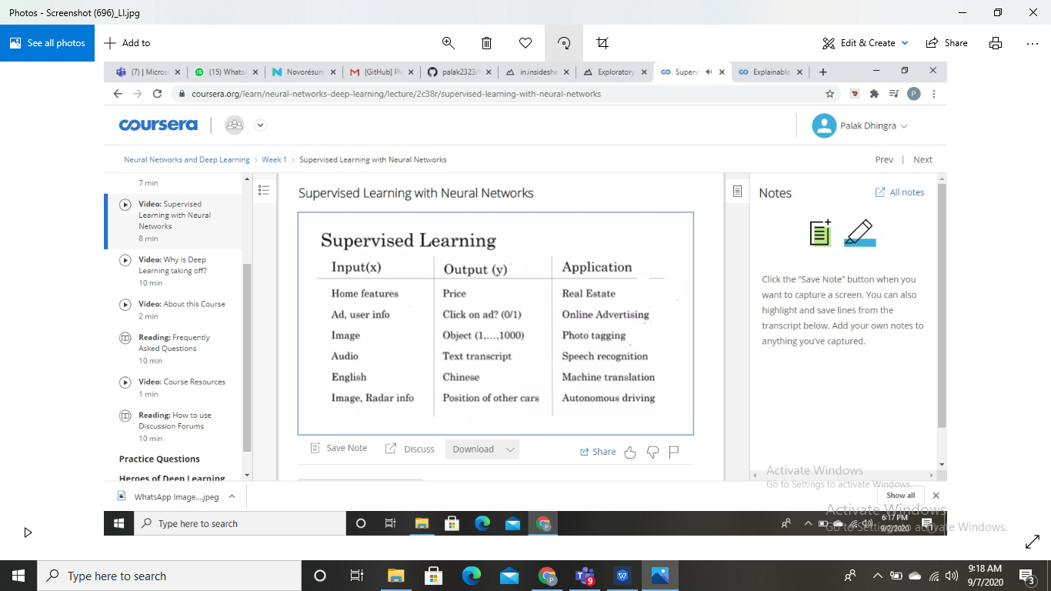

**Deep Learning**

Deep learning is part of a broader family of machine learning methods based on artificial neural networks with representation learning. Learning can be supervised, semi-supervised or unsupervised. It mimics the workings of the human brain in processing data for use in detecting objects, recognizing speech, translating languages, and making decisions.

**Why Deep Learning?**

Deep learning is part of a broader family of machine learning methods based on artificial neural networks with representation learning. **Deep learning** allows machines to solve complex problems even when using a data set that is very diverse, unstructured and inter-connected.

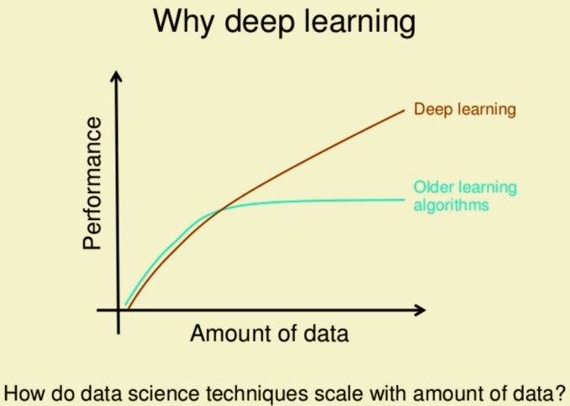

**Quiz Outcome**

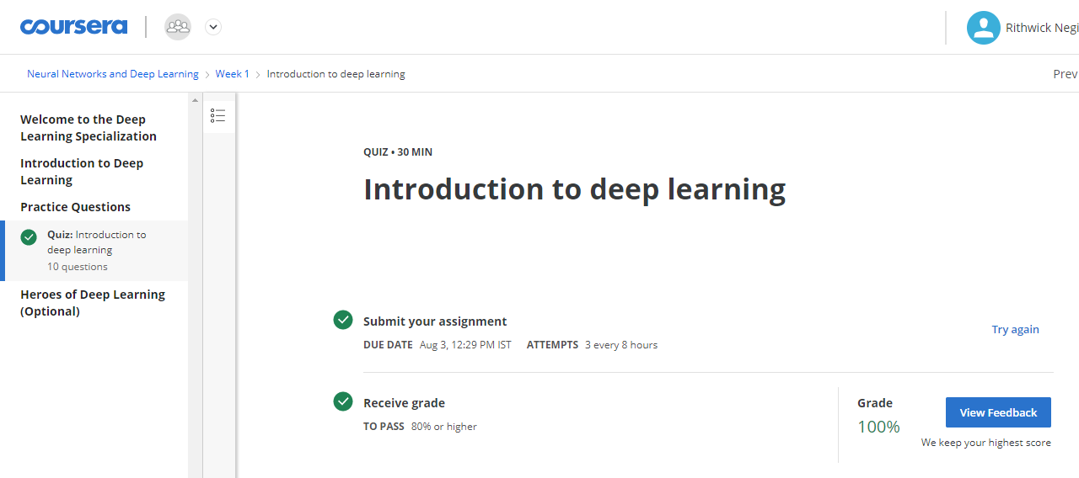

**WEEK-2**

**Key Points:-**

* Build a logistic regression model, structured as a shallow neural network
* Implement the main steps of an ML algorithm, including making predictions, derivative computation, and gradient descent.
* Implement computationally efficient, highly vectorized, versions of models.
* Understand how to compute derivatives for logistic regression, using a backpropagation mindset.
* Become familiar with Python and Numpy
* Work with iPython Notebooks
* Be able to implement vectorization across multiple training examples

**Binary Classification**

Binary classification is the task of classifying the elements of a set into two groups on the basis of a classification rule. In binary classification, our goal is to learn a classifier that can input an image represented by this feature vector x. And predict whether the corresponding label y is 1 or 0

**Logistic Regression**

Logistic Regression is a mathematical model used in statistics to estimate (guess) the probability of an event occurring having been given some previous data. Logistic Regression works with binary data, where either the event happens (1) or the event does not happen (0).

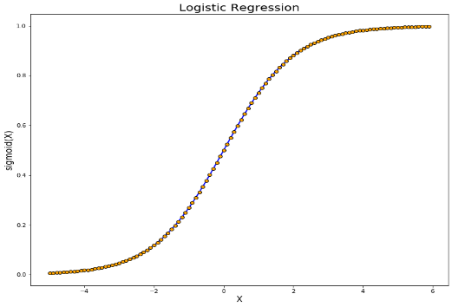

**Sigmoid Function**

In order to map predicted values to probabilities, we use the Sigmoid function. The function maps any real value into another value between 0 and 1. In machine learning, we use sigmoid to map predictions to probabilities. For example, if we were creating a neural network-based “cat(1) vs. not-cat(0)”

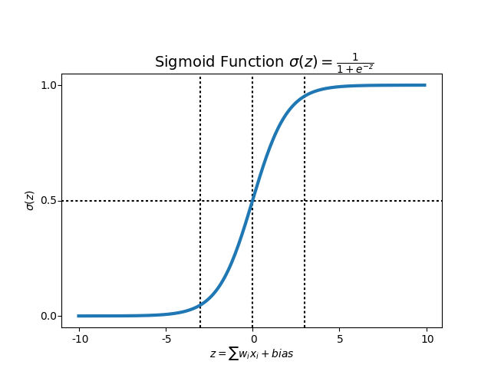

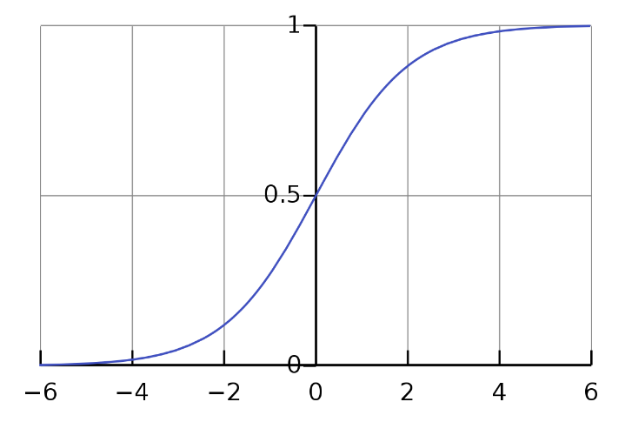

**Derivative**

The derivative is the instantaneous rate of change of a function with respect to one of its variables. This is equivalent to finding the slope of the tangent line to the function at a point.It is basically the slope of a function at a time.

**Gradient Descent**

Gradient descent is an optimization algorithm used to minimize some function by iteratively moving in the direction of steepest descent as defined by the negative of the gradient. In machine learning, we use gradient descent to update the parameters of our model.

The main goal of Gradient descent is to minimize the cost value. i.e. min J(θ).

**Cost Function**

The Cost Function represents optimization objective i.e. we create a cost function and minimize it so that we can develop an accurate model with minimum error. The Cost function is the average of the loss functions of the entire training set.

**Loss Function**

Loss Function is a method of evaluating how well specific algorithm models the given data. If predictions deviates too much from actual results, loss function would cough up a very large number. There's no one-size-fits-all loss function to algorithms in machine learning.

1. For linear functions

 (where y: actual value; y^: predicted value)

1. Non linear function



**Vectorization**

Vectorization is a technique by which you can make your code execute fast. In machine learning, there’s a concept of an optimization algorithm that tries to reduce the error and computes to get the best parameters for the machine learning model.

Most of the NumPy library methods are vectorised version.

**Broadcasting**

Broadcasting is a mechanism which allows tensors with different numbers of dimensions to be added or multiplied together by (virtually) replicating the smaller tensor along the dimensions that it is lacking.

**Quiz Outcome**

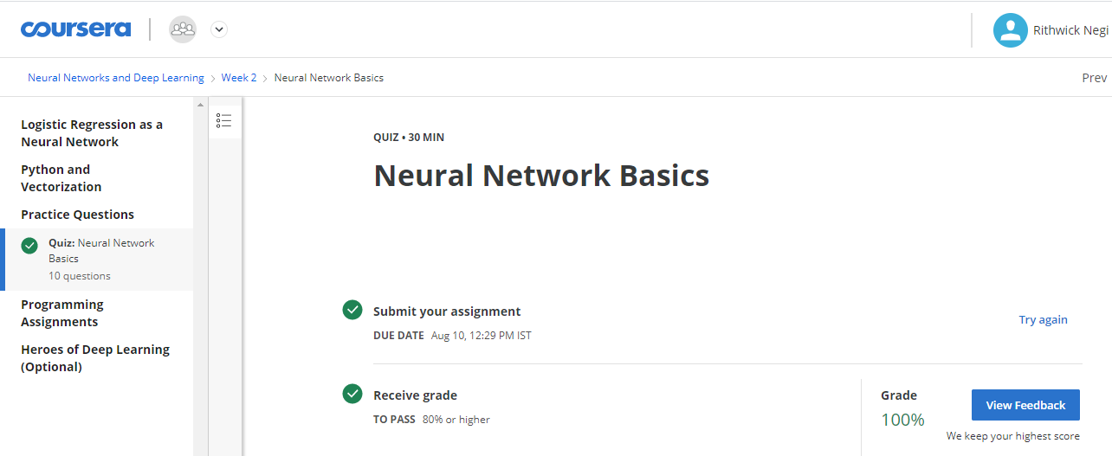

**Programming assignment:**  https://github.com/RithwickNegi/summer-internship-sem5/blob/master/week1.ipynb

**Programming Assignment Outcome**

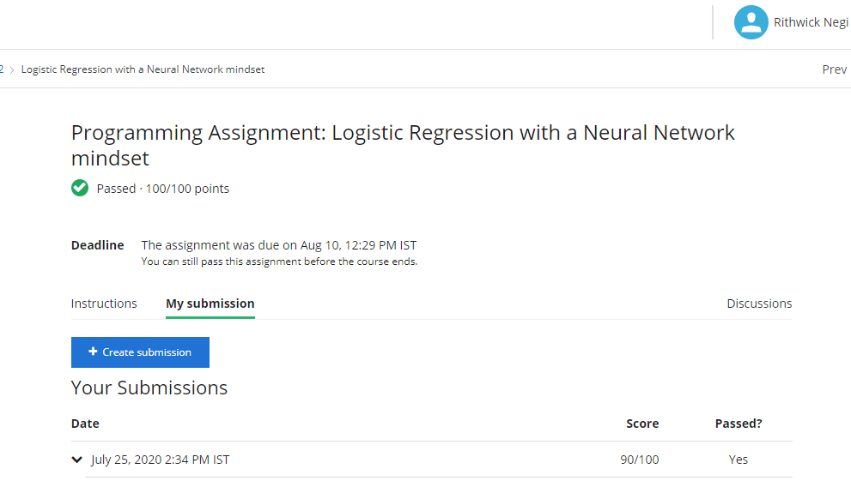

**WEEK-3**

### **Key Concepts**

* Understand hidden units and hidden layers
* Be able to apply a variety of activation functions in a neural network.
* Build your first forward and backward propagation with a hidden layer
* Apply random initialization to your neural network
* Become fluent with Deep Learning notations and Neural Network Representations
* Build and train a neural network with one hidden layer.

**Shallow Neural Network**

Shallow neural networks is a term used to describe neural network that usually have only one hidden layer as opposed to deep neural network which have several hidden layers.

**Logistic Regression(No Hidden Layer)**

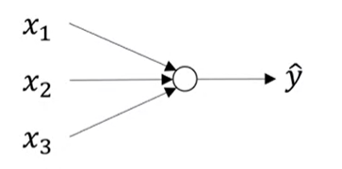 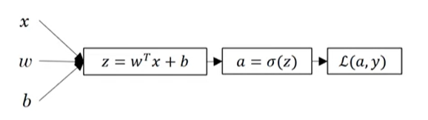

**Logistic Regression(1 Hidden Layer)**

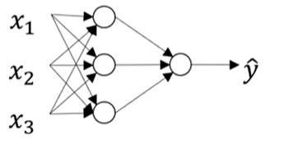 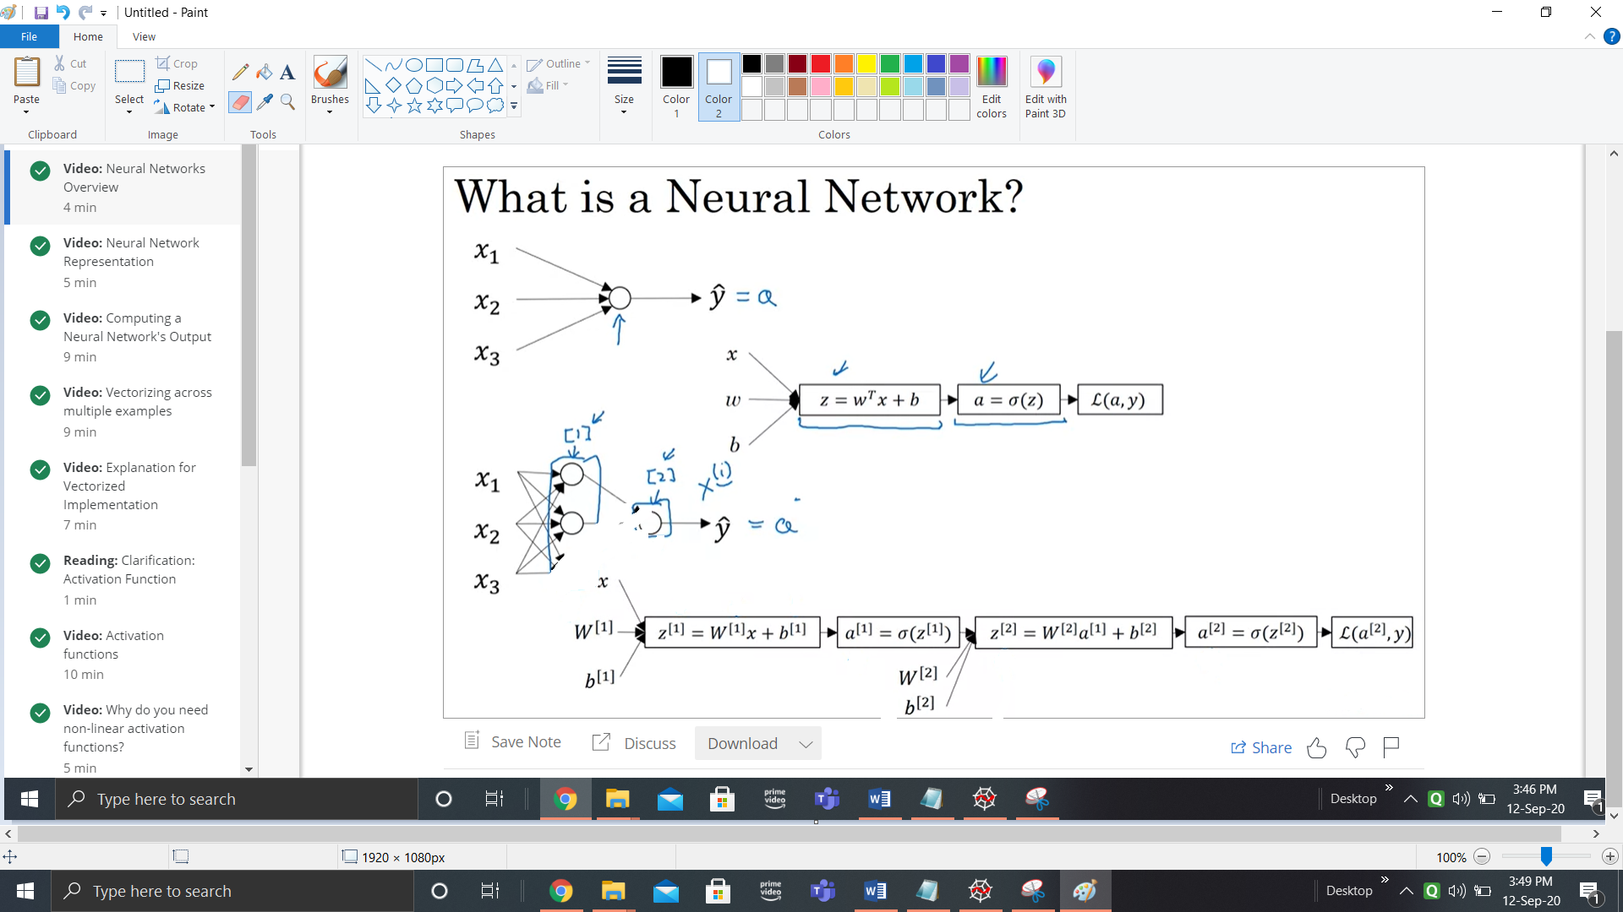

**Neural Network Representation**

Neural networks are a biologically-inspired algorithm that attempt to mimic the functions of neurons in the brain. Each neuron acts as a computational unit, accepting input from the dendrites and outputting signal through the axon terminals.

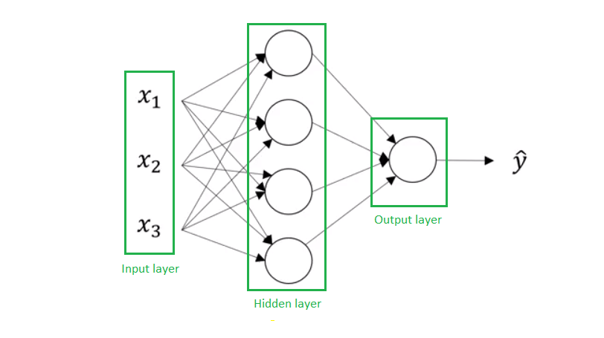

**Neuron Computation**

A neuron is a combination of 2 parts:

* The First part computes the output Z, using inputs and weights.
* The Second part computes the activation on Z,to give output.

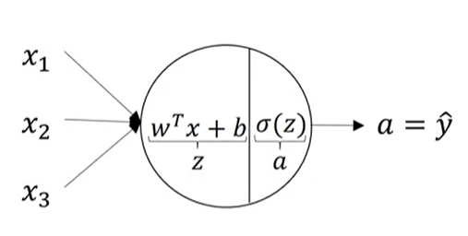

**Neuron Computation (In Hidden Layer)**

The larger the number of hidden layers in a neural network, the longer it will take for the neural network to produce the output and the more complex problems the neural network can solve.

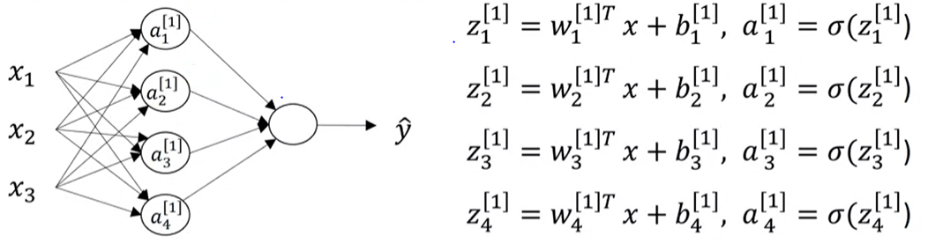

As these 4 equations seem redundant. Therefore we will vectorise them in order to make them easy

**Z[i] = W[i]Tx +b[i]**

**A[i] = σ(Z[i])**

**Activation Function**

Activation functions are mathematical equations that determine the output of a neural network. The function is attached to each neuron in the network, and determines whether it should be activated (“fired”) or not, based on whether each neuron's input is relevant for the model's prediction.

There are many activation functions that can be used. These include Sigmoid, Tanh, ReLU, Leaky ReLU and many others. It is not mandatory to use a particular activation function for all layers. You can select an activation function for a particular layer and a different activation for another layer and so on.

**Need of Activation Function**

Without the activation functions, our shallow neural network can be represented as:

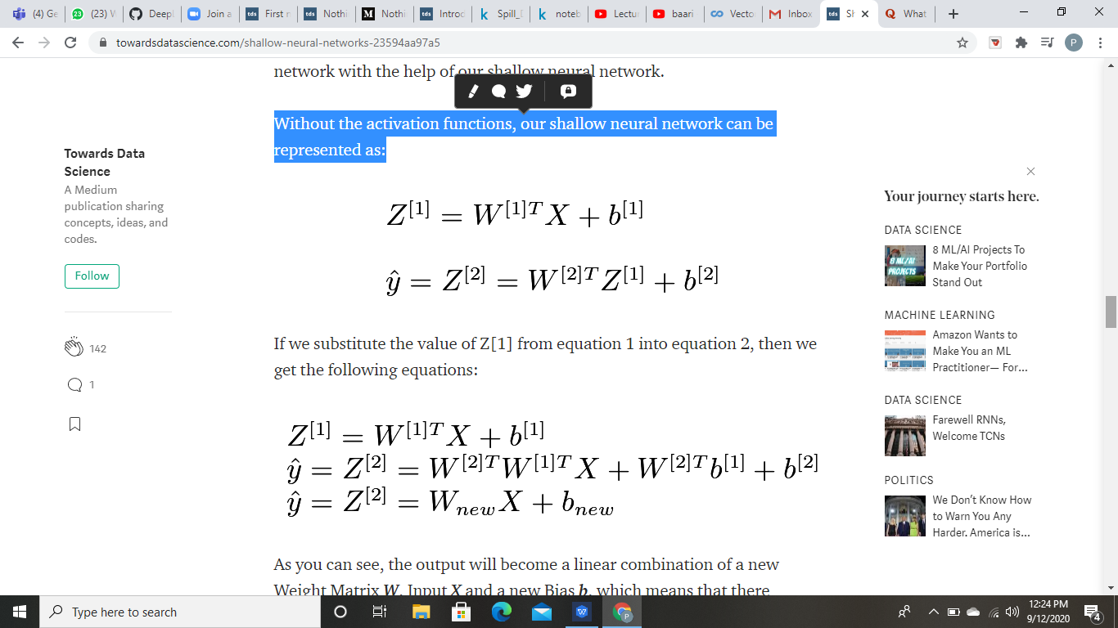

If we substitute the value of Z[1] from equation 1 into equation 2, then we get the following equations:



**Sigmoid Function**

Sigmoid can lead us to gradient decent problem where the updates are so low. It range between 0 and 1.

**Tanh Function**

The Tanh Function, is another type of AF. It is a smoother, zero-centered function having a range between -1 to 1.It turns out that the tanh activation usually works better than sigmoid activation function for hidden units because the mean of its output is closer to zero, and so it centers the data better for the next layer.

**ReLU Function**

ReLU Function is responsible for transforming the summed weighted input from the node into the activation of the node or output for that input.

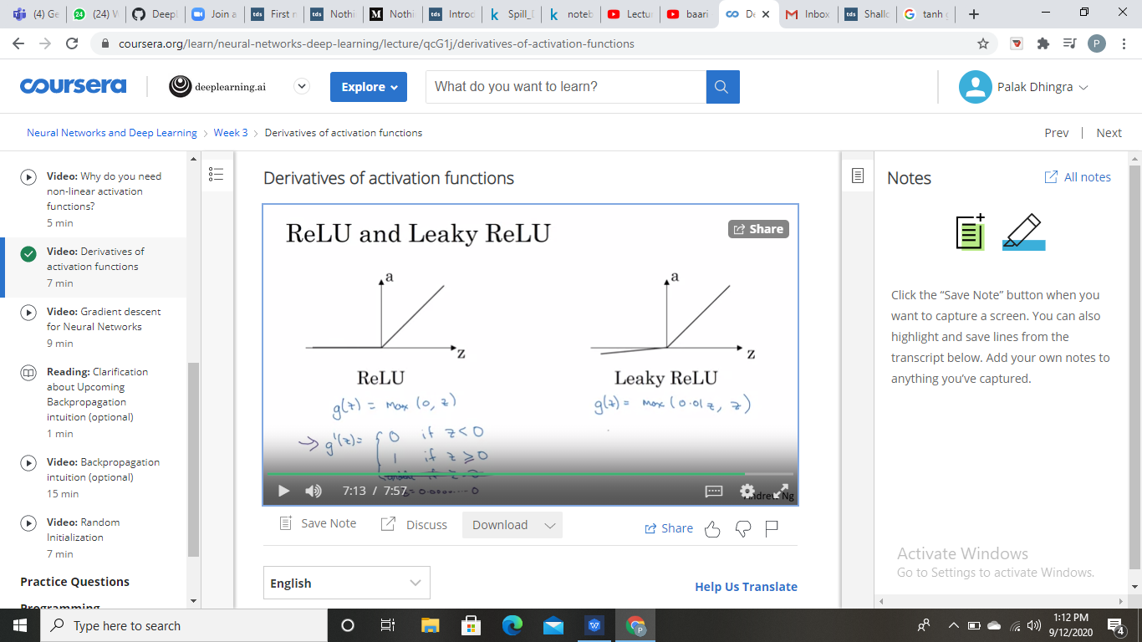

**Quiz Outcome**

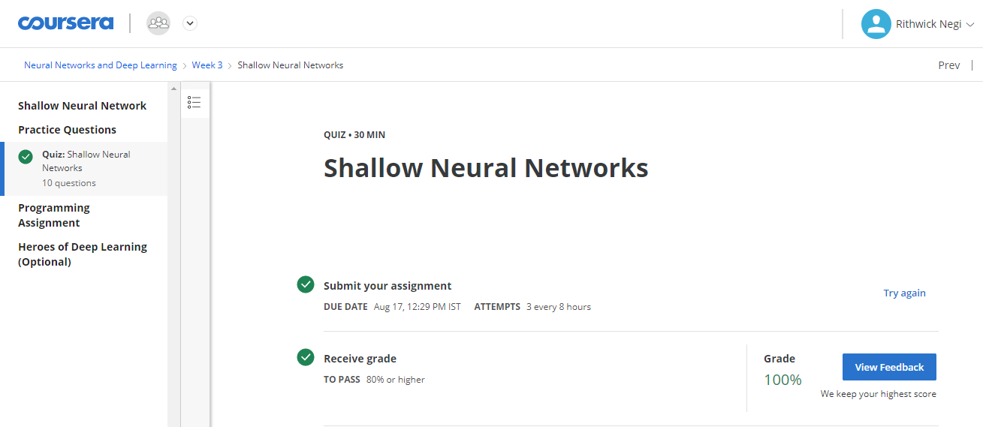

**Programming Assignment:**  https://github.com/RithwickNegi/summer-internship-sem5/blob/master/week2.ipynb

**Programming Assignment Outcome**

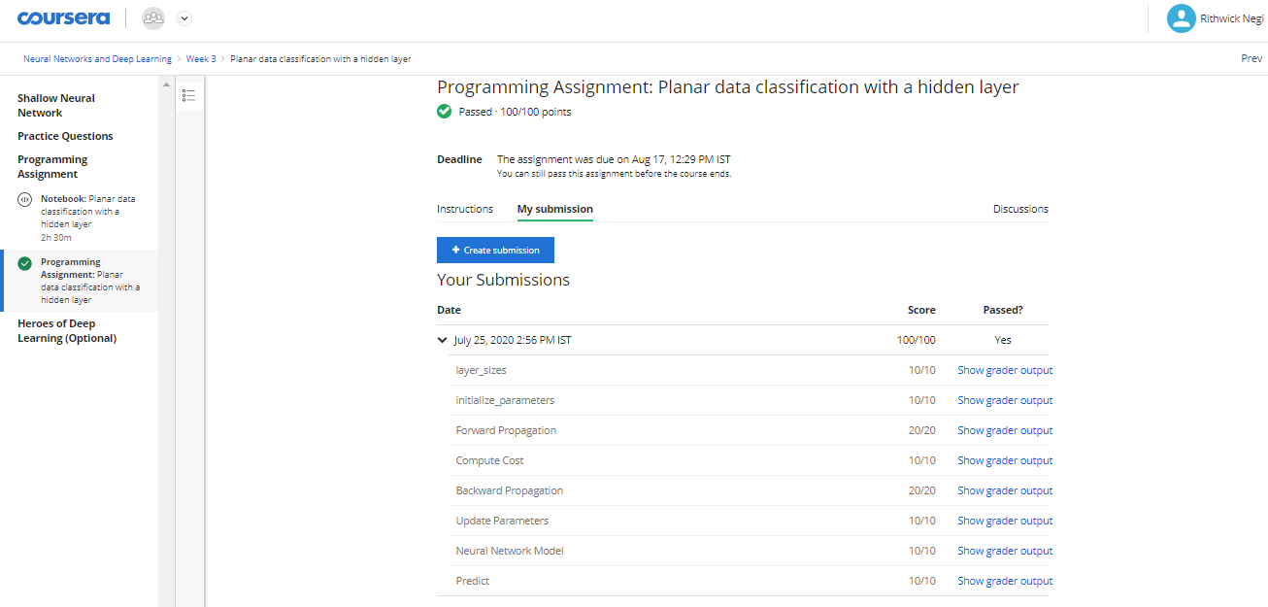

**WEEK-4**

### **Key Concepts**

* See deep neural networks as successive blocks put one after each other
* Build and train a deep L-layer Neural Network
* Analyse matrix and vector dimensions to check neural network implementations.
* Understand how to use a cache to pass information from forward propagation to back propagation.
* Understand the role of hyperparameters in deep learning

**Deep Neural Network**

A deep neural network (DNN) is an artificial neural network (ANN) with multiple layers between the input and output layers. The DNN finds the correct mathematical manipulation to turn the input into the output, whether it be a linear relationship or a non-linear relationship.

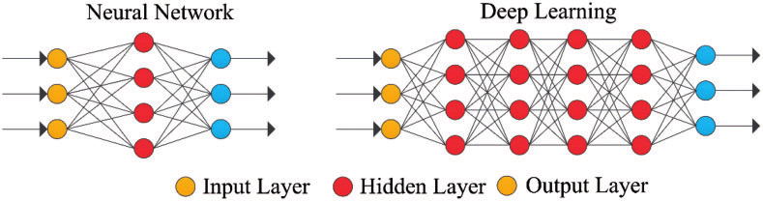



**Forward Propagation**

In Forward Propogation, forward implies moving ahead and propagation is a term for saying spreading of anything. Forward propagation means we are moving in only one direction, from input to the output, in a neural network.

Forward propagation general rule for one input:

* z[l] = W[l]a[l-1] + b[l]
* a[l] = g[l](a[l])

Forward propagation general rule for m inputs:

* Z[l] = W[l]A[l-1] + B[l]
* A[l] = g[l](A[l])

Matrix dimensions:-

* Dimension of W is (n[l],n[l-1])
* Dimension of b is (n[l],1)
* dw has the same shape as W, while db is the same shape as b
* Dimension of Z[l], A[l], dZ[l], and dA[l] is (n[l],m)

**Deep Representation**

Deep neural Network makes relations with data from simpler to complex. In each layer it tries to make a relation with the previous layer.

Example:-

* Face recognition application: Image ==> Edges ==> Face parts ==> Faces ==> desired face

**Backward propagation**

Back-propagation is the essence of neural net training. It is the practice of fine-tuning the weights of a neural net based on the error rate (i.e. loss) obtained in the previous epoch (i.e. iteration). Proper tuning of the weights ensures lower error rates, making the model reliable by increasing its generalization. It is used to calculate the gradient of the loss function with respect to the parameters.

**Quiz Outcome**

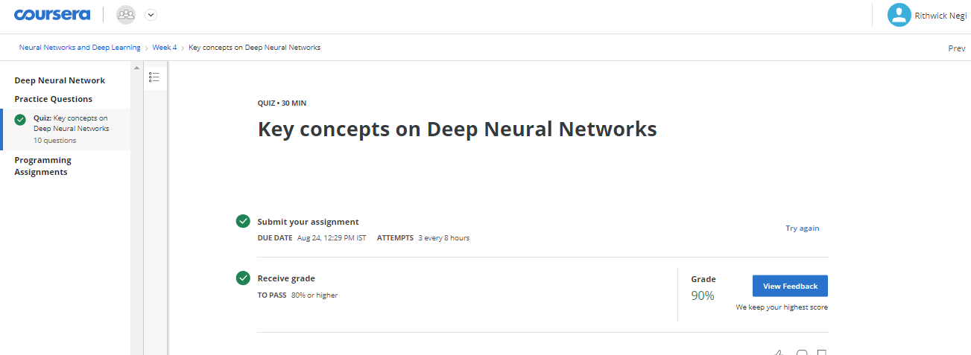

**Programming Assignments:** https://github.com/RithwickNegi/summer-internship-sem5/blob/master/week3.ipynb

https://github.com/RithwickNegi/summer-internship-sem5/blob/master/week4.ipynb

**Programming Assignment-1 Outcome**

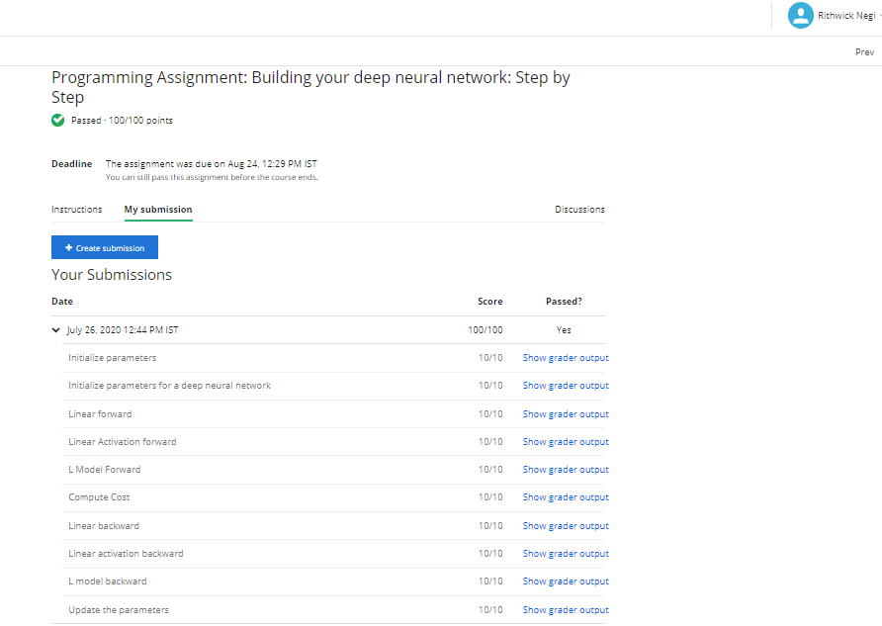

**Programming Assignment-2 Outcome**

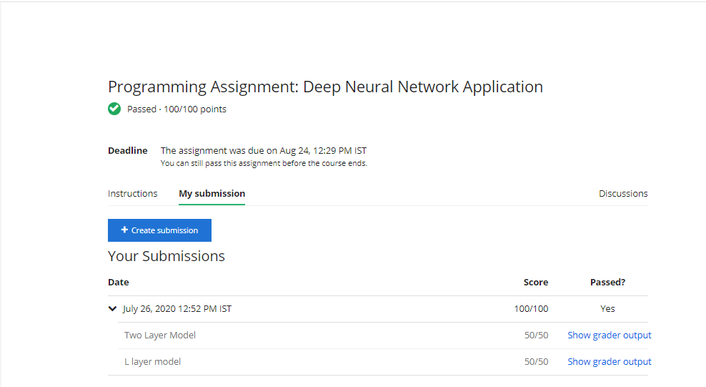

**Outcome on new Dataset**

***Shallow Neural Network Planar Classification***

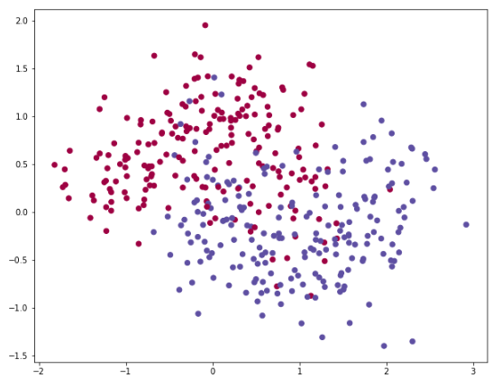

**Project Link:** https://github.com/RithwickNegi/summer-internship-sem5/blob/master/intership%20project.ipynb

**CONCLUSION**

By the end of this specialization course, I have a good understanding of deep learning and neural networks. Not only was I able to execute deep learning using python but I was also able to understand how the calculations are done in neurons and how the output of a given problem is generated. This course gave me a basic idea of neural networks. The concepts taught in this course were to the point and assignments were very interesting.

**REFERENCE**

* <https://www.coursera.org/learn/neural-networks-deep-learning/home/welcome>
* <https://towardsdatascience.com/introducing-deep-learning-and-neural-networks-deep-learning-for-rookies-1-bd68f9cf5883>
* <https://www.geeksforgeeks.org/introduction-deep-learning/>
* <https://pathmind.com/wiki/neural-network>

|  |  |  |  |
| --- | --- | --- | --- |
| Project Daily Task | | | |
| Date | | **Day** | **Work** |
| 2nd july,2020 | | Thursday | Started with Introduction and downloaded reading material. |
| 7th july,2020 | | Tuesday | Quiz for week 1 |
| 10th july,2020 | | Friday | Quiz for week 2 |
| 15th,july 2020 | | Wednesday | Program file for week 2 |
| 17rd,july 2020 | | Friday | Quiz for week 3 |
| 20th july 2020 | | Monday | Program file 1 completed for week 3 |
| 22nd july 2020 | | Wednesday | Program file 2 completed for week 3 |
| 23rd july 2020 | | Thursday | Week 4 quiz |
| 26th july 2020 | | Sunday | Program file completed for week 4 |
| 26th july,2020 | | Sunday | Certificate isuued |
|  |
| 16th august 2020 | | Sunday | Started with making report |
| …………….. | | …………………….. | ………………………………………………………… |
| 1st sept 2020 | | Tuesday | Finished with report making |
| …………….. | | …………………….. | ………………………………………………………… |
| 15th sept 2020 | | Tuesday | Made ppt for evaluation |
| …………….. | | …………………….. | ………………………………………………………… |
| 24th sept 2020 | | Thursday | Final evaluation day |
| …………….. | | …………………….. | ………………………………………………………… |
|  | |  |  |
| …………….. | | …………………….. | ………………………………………………………… |
|  | |  |  |
| …………….. | | …………………….. | ………………………………………………………… |
|  | |  |  |
| …………….. | | …………………….. | ………………………………………………………… |
|  | |  |  |
| …………….. | | …………………….. | ………………………………………………………… |
|  | |  |  |
|  | |  |  |